CSE 397 Team 3 – Ryan Funk, Levi Johnson, Jerry Lane, Cayleigh Leishman, Gerin Wilde, Brycen Williams

December 12, 2024

**Software Design Document for NASA Psyche Sampling Lander Simulator**

Version 2.4

Contents

**1. Introduction** 2

**1.1 Purpose** 2

**1.2 Scope** 2

**1.3 Limitations** 2

**2. Overall System Architecture** 3

**2.1 Architectural Style** 3

**2.2 Component Diagram** 3

**2.3 Technologies** 4

**3. Detailed Design** 5

**3.1 User Interface Design** 5

3.1.1 Home Page 5

3.1.2 Main Menu 6

3.1.3 Configuration Menu 6

**3.2 Functionality Design** 8

3.2.1 Cookie Management 8

3.2.2 Error Handling 8

**3.3 Simulation Controls** 8

3.3.1 Simulation Parameters 8

3.3.2 Keyboard Controls 11

3.3.3 Simulation Management 11

**3.4 Data and Simulation Visuals** 11

3.4.1 Visualization Windows 11

**3.5 Front-end Structure** 12

3.5.1 Home page 12

3.5.2 API request JSON format 12

**4. Non-Functional Requirements** 14

**4.1 Performance** 14

**4.2 Usability** 14

**5. Validation Strategy** 15

**5.1 Validation Techniques** 15

**5.2 Success Criteria** 15

**6. Conclusion** 15

Software Design Document (SDD) for NASA Psyche Sampling Lander Simulator

# **1. Introduction**

## **1.1 Purpose**

The purpose of this SDD is to provide a comprehensive overview of the design and architecture of the web-based spacecraft simulator for the Psyche mission, ensuring it meets the outlined requirements in the SRS.

## **1.2 Scope**

This document details the software architecture, system design, user interface, and interactions necessary to implement the functionalities described in the SRS. It serves as a guide for developers, testers, and project stakeholders.

## **1.3 Limitations**

This document shows implementation only of those requirements outlined in the SRS as being of Critical or High priority. In an effort to advance the development of this application, some features of Normal priority are also included in this version.

# **2. Overall System Architecture**

## **2.1 Architectural Style**

The simulator will adopt a Model-View-Controller (MVC) architecture, separating concerns among data management, user interface, and user interaction.

## **2.2 Component Diagram**

**Frontend:**

Model: Handles data, simple logic, and provides forms.

View: Graphic display for simulation and data visualization.

Controller: Manages user input and interacts with the Model to update the View.

**Backend:**

Model: Contains the static data used in physics calculations, API return format for data.

View: API.

Controller: Business logic, and physics calculations.

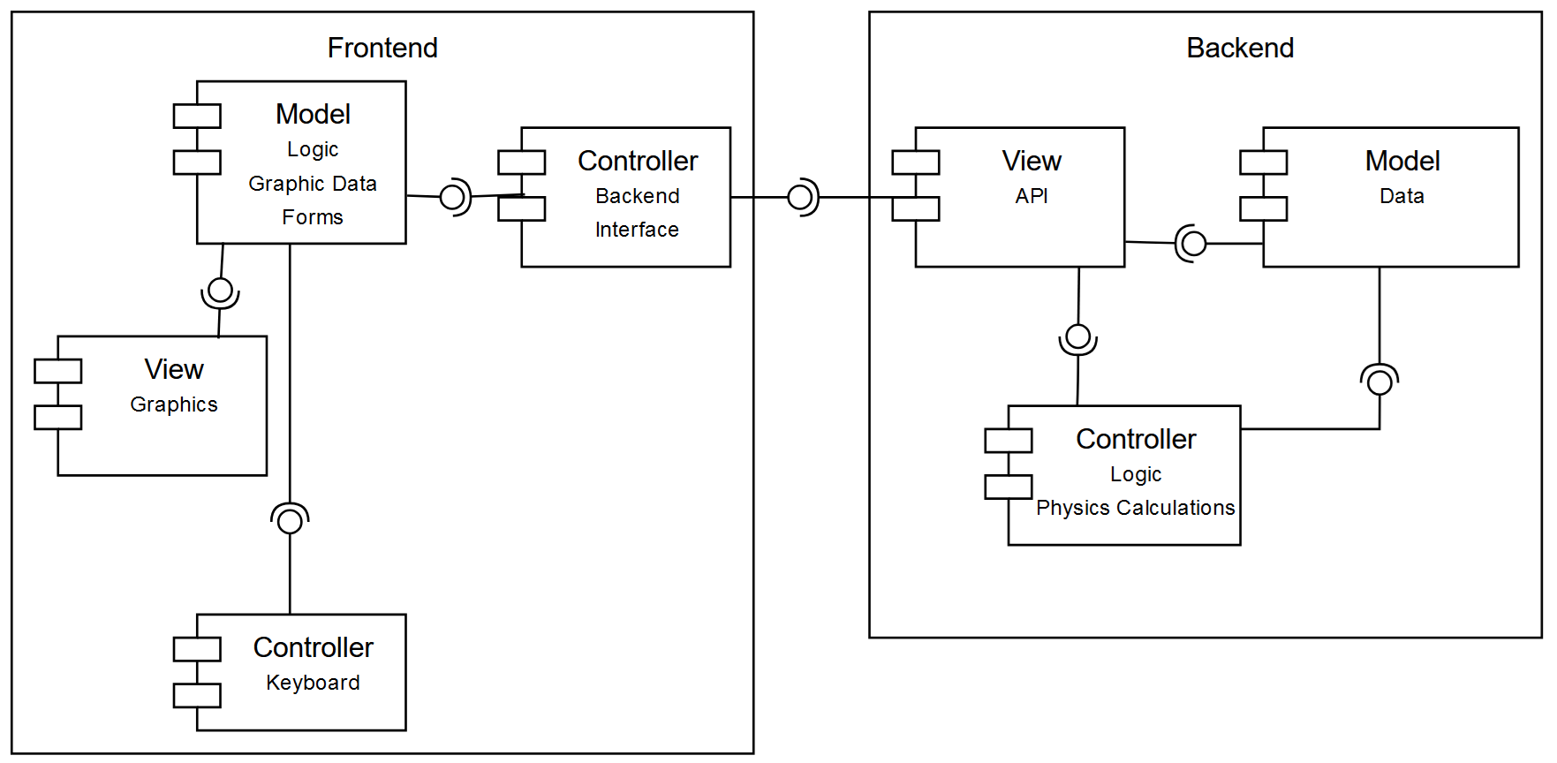 **Viewpoint:**

Figure 1 – Architecture Overview

## **2.3 Technologies**

Frontend: HTML5, CSS3, JavaScript (with React, ReactDOM, Vite, Three.js libraries)

Backend: ASP.NET Core

Simulation Engine: Three.js, WebGL for rendering of simulation view

# **3. Detailed Design**

## **3.1 User Interface Design**

### 3.1.1 Home Page

SRS Requirements: 3.1.1.1, 3.1.1.4, 3.1.10.3, 3.2.1.2, 3.2.2.1

Components: Welcome message, NASA and Psyche Mission logos, ***Activate Simulator*** button, ***Learn more about NASA’s mission to Psyche*** button, and ***About this application*** button.

Design Guidelines: Adhere to WCAG standards for accessibility.

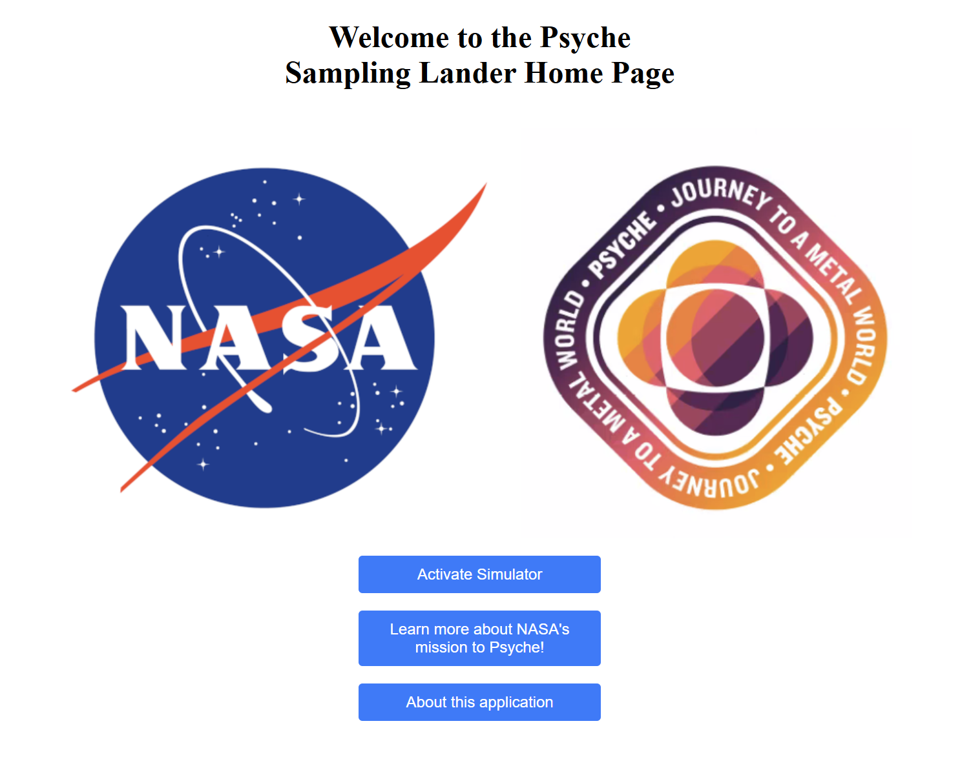 Viewpoint:

Figure 2 – Home Page

### 3.1.2 Main Menu

SRS Requirements: 3.1.4.3, 3.1.7.1, 3.1.7.3, 3.2.2.1

**Description**: The Main Menu will be the first menu option the user sees upon access.

**Elements**: The Main Menu will have a dropdown menu for difficulty options and five button controls as listed:

* Difficulty dropdown menu
  + Expert
  + Intermediate
  + Novice
* Buttons for five options:
  + Load Mission
  + Write Mission
  + Configuration
  + Start Simulation
  + Exit

Viewpoint:

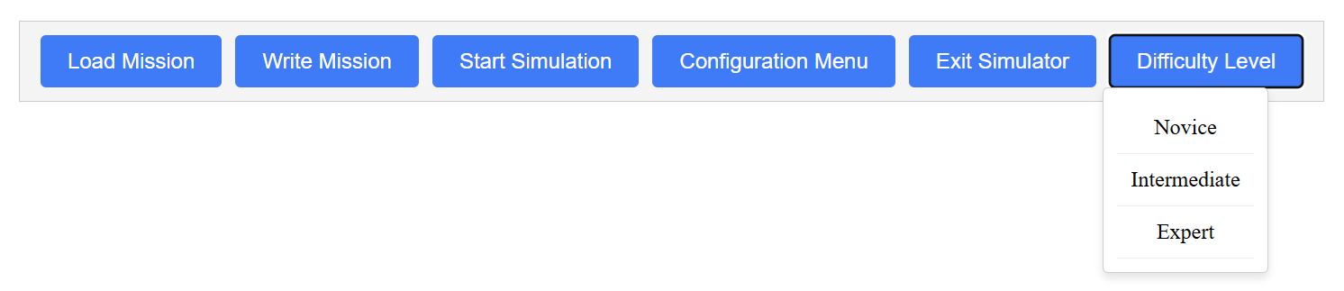

Figure 3 – Main Menu

### 3.1.3 Configuration Menu

SRS Requirement: 3.1.7.2, 3.2.2.1

Description: After the Configuration Menu button is pressed on the Main Menu, the Configuration Menu is shown, allowing users to set their parameters themselves. If the Novice skill level is selected (default), the Configuration Menu will be disabled for input.

Viewpoint:

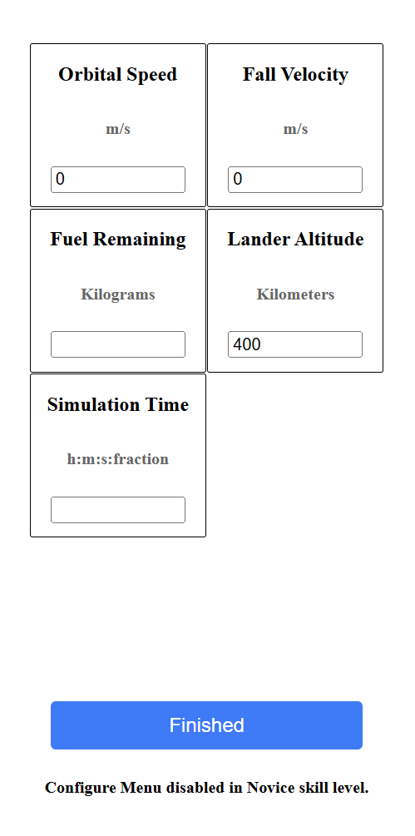

Figure 4 – Configuration Menu

## **3.2 Functionality Design**

### 3.2.1 Cookie Management

SRS Requirements: 3.1.2.1, 3.1.2.2, 3.1.2.3

Cookies will only be used for functionality, so there is no need to offer users a choice to opt out. In this application, the cookies will be used to store the session ID. We may also use the cookies to track unique visits to our application, so NASA could evaluate public interest in the Psyche Mission.

### 3.2.2 Error Handling

SRS Requirements: 3.1.3.1, 3.1.3.2, 3.1.3.3, 3.1.8.1, 3.1.9.1

Purpose: Implement a centralized error handling mechanism for user information and feedback.

Description: Handle all errors through the following:

* Display server outage with a popup window requiring user acknowledgement.
* In case of guest sign on, auto-set limited features to novice default settings.
* When input configuration data is invalid, warn user with popup and reset to default value.
* Should the lander go too far off course or sustain damage, the user is prompted by popup window that the mission has failed. The application is set to default parameters.

## **3.3 Simulation Controls**

### 3.3.1 Simulation Parameters

SRS Requirements:3.1.5.2, 3.1.5.4, 3.2.2.1

*Input and Display Handling*

Create a form to input and display the below parameters validated in real-time.

*Developer Defined (Constant) Parameters*

These parameters are to be defined by the developer and unable to be tweaked by the standard user.

* Acceleration due to gravity of Psyche (float)
* Average diameter of Psyche (float)
* Rotation speed of Psyche (float)
* Mass of the spacecraft lander (float)
* Amount of fuel for thrusters designated for landing (int)
* Minimum force from landing impact that the lander can sustain (int)
* Diameter of landing feet (float)
* Minimum/maximum radial distances the lander can start at (float)
* Maximum level of thrust that can be exerted (int)
* Maximum distance of the lander from Psyche that's considered too far (out of bounds threshold) (float)

*User Defined (Configurable) Parameters*

These parameters are to be adjusted by the user before (and perhaps during for some) the simulation.

* Starting location of the lander: The location of the lander will be determined using the polar coordinate system. The coordinates for such are as follows.
  + Radial distance (ρ) (float)
  + Polar angle (θ) (float)
* Facing angle of the lander (same conditions from lander location apply here)
* Distance of the lander from Psyche in which to turn on thrusters (float)
* Level of thrust to decrease gravitational acceleration (float)
* Angle of thrusters relative to the lander (float)

*Real-Time (Variable) Parameters*

These parameters are those that update in real time during the simulation, not defined or adjusted by a developer or user, and displayed to the user as information during runtime.

* Current acceleration of the lander (float)
* Current velocity of the lander (float)
* Current level of thrust (float)
* Amount of fuel remaining (int)
* Amount of damage the lander has sustained (int)
* Distance between the lander and Psyche (float)
* Time elapsed (float)

*Conclusion*

With these parameters considered, implications can be made regarding the overall design.

* The simulation will run in two dimensions.
* Psyche's surface won't be perfectly symmetrical, making the facing angle of the lander and its rate of descent conditional by its starting location.
* The lander will start at a fixed position without any additional velocities due to orbit or otherwise.
* The lander must make a soft landing below the force of impact sustain threshold.
* The lander must make a secure landing without losing balance and toppling over.

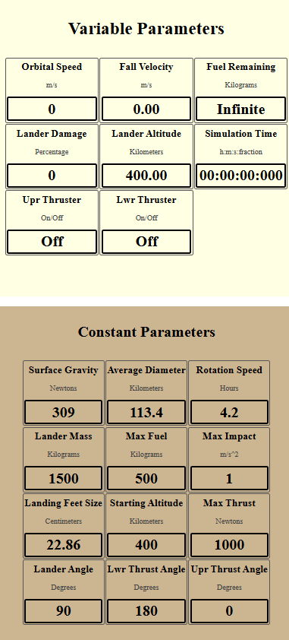Viewpoint:

Figure 6 – Parameter Panel of Simulator

### 3.3.2 Keyboard Controls

SRS Requirement: 3.1.7.4, 3.1.7.6

Description: User will have access to keyboard controls for real-time adjustment of thrusters. Specific keys will be identified as individual thrusters, and the cursor left and right keys will act to increase and decrease thruster angles, with the cursor down arrow acting to turn the upper thruster on/off and the cursor up key to turn the lower thruster on/off.

### 3.3.3 Simulation Management

SRS Requirement: 3.1.7.5, 3.2.2.1

Control Functions: Implement start, pause, exit, and resume features in the application using state management.

 Viewpoint:

Figure 7 – Simulation Control Panel of Simulator

## **3.4 Data and Simulation Visuals**

### 3.4.1 Visualization Windows

SRS Requirement: 3.1.5.1, 3.1.5.2, 3.1.5.3, 3.1.5.4, 3.1.5.5, 3.1.7.3, 3.2.1.3, 3.2.2.1

Window Components: Two main windows, one for data readout and one for simulation visuals. (Note: Viewpoint includes the simulation controls from Section 3.3.3 in addition.)

Data Parameters: Display constant metrics like spacecraft weight, Psyche gravity, Psyche rotation, and maximum landing speed. Show real-time data such as distance from Psyche, descent speed, fuel remaining, rotation direction, rotation speed, and all thruster actions.

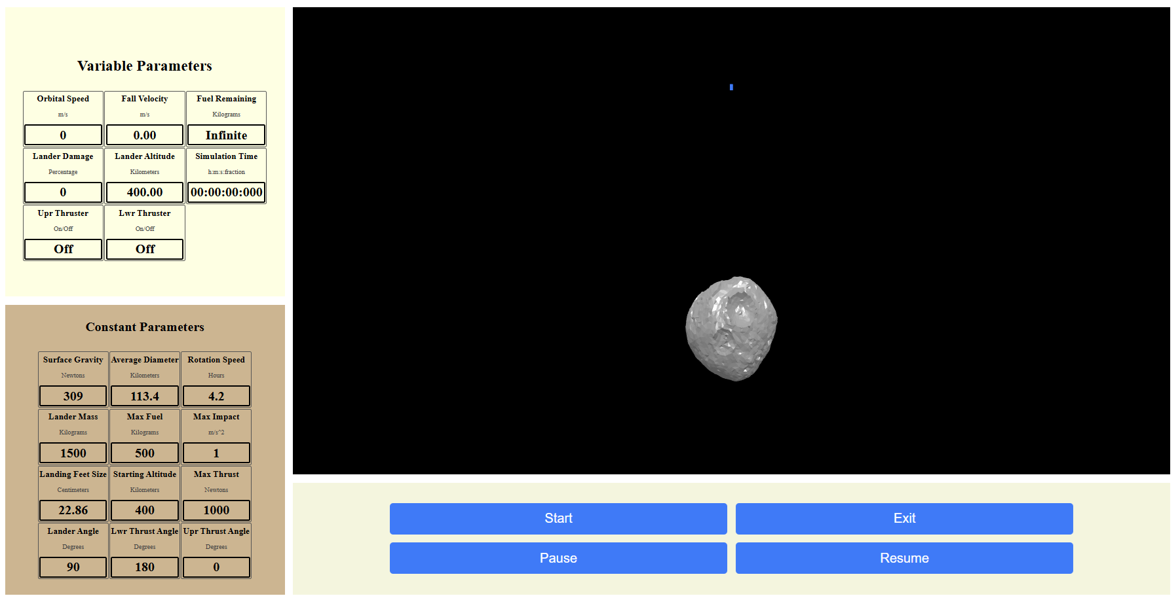Viewpoint:

Figure 8 – Simulation Screen with Parameter Panel, Simulation Visualization Screen, and Simulator Controls

## **3.5 Front-end Structure**

### 3.5.1 Home page

SRS Requirements: 3.1.1.1, 3.1.1.4

Description: When user navigates to the IP address where the front-end code is stored, the browser window will show the home page as noted in section 3.1.1 of this document. If the user clicks on the ***Use Simulator*** button, the Main Menu is called. If the Configure Menu button is pressed, the Configure Menu is display, and when the Finished button is pressed, the Main Menu is displayed once more. When the Start Simulation button is pressed, the Simulation component displays the Parameter, Simulation View, and Simulation Controls.

Viewpoint: (See Figures 2, 3, 4, 5, 6, 7, and 8)

### 3.5.2 API request JSON format

SRS Requirements: 3.1.5.1, 3.1.5.2

Description: During an active simulation, calculations will be performed requested by the front-end and performed in the back-end via an API call. The format of the JSON request will be as noted in this section, however, it shall not be fully implemented in this version (2.4), but shall be ready for implementation on a succeeding version.

Viewpoint:

API Request JSON:

{

"user_id": (int)

"time": "time simulation began" (time string),

"current": "current time" (time string),

"last": "time of back-end calculation response" (time string), *<- 1st call, time sim began*

"upperThrusterOn": true/false (bool),

"lowerThrusterOn": true/false (bool),

"altitude": "current altitude in kilometers" (double),

"prior": "previous height response from back-end" (double), *<- 1st call, 400.0*

"fuel": "current fuel in kg" (double),

}

]

}

Response JSON:

{

"user_id": (int)

"calculation": " time calculations performed" (time string),

"velocity": "falling velocity" (double),

"fuel": "fuel remaining" (double),

"damage": "0% / actual damage %" (double),

"height": "new altitude in kilometers" (double),

"elapsed": "time since simulation began" (time string),

}

]

}

# **4. Non-Functional Requirements**

## **4.1 Performance**

Load Testing: The system should handle 100 simultaneous users without performance degradation.

Response Times: Home page load within 3 seconds, real-time updates on parameter changes.

## **4.2 Usability**

User Testing: Regular usability testing with target user groups to refine the interface, particularly regarding accessibility.

# **5. Validation Strategy**

## **5.1 Validation Techniques**

Unit Testing: For individual components.

Integration Testing: For interactions between components.

User Acceptance Testing (UAT): Involving end-users to validate against SRS.

## **5.2 Success Criteria**

All critical requirements must be verified.

User feedback must indicate satisfactory usability and engagement.

# **6. Conclusion**

This SDD outlines the architectural and design approach for the NASA Psyche Mission Simulator, providing a clear roadmap for development and implementation. By adhering to these specifications, the project aims to deliver a robust and engaging educational tool for various user groups.